** PRESS RELEASE ** PRESS RELEASE **

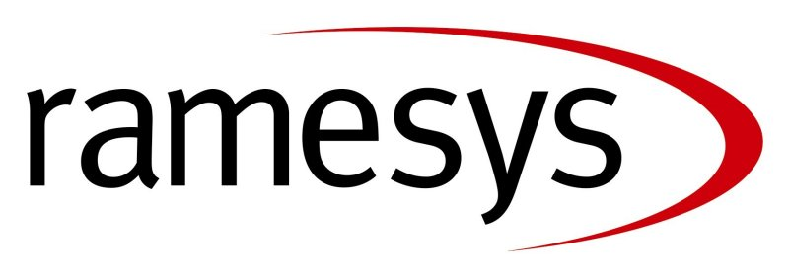

Ramesys named as preferred ICT bidder for Manchester City’s £200 Million Building Schools for the Future Programme.

Ramesys – one of the UK’s leading education solution providers has been named as Manchester City Council’s preferred Information and Communications Technology (ICT) partner for the Council’s £200 Million Building Schools for the Future (BSF) programme.

As the selected ICT partner, Ramesys is set to transform the learning experience for the teachers and learners included in this first phase with pedagogical ICT services and solutions, including a city- wide Managed Learning Environment based on the award winning Ramesys Assimilate Learning Platform product.

The solution will support the City Council’s transformation vision for an e-confident city, offering huge opportunities for service improvement as well as making e-learning possible in a wide range of locations including homes, schools, colleges and libraries.

The seventeen schools included in this first phase will also benefit from Ramesys’ comprehensive Managed Services, allowing the City’s teachers and leaders to focus on the conveyance of exceptional education services to the community.

Bill Donoghue, CEO, Ramesys, commented: “We are delighted to be helping Manchester City Council transform its schools. We are extremely excited to be appointed as preferred bidder for this important partnership with one of the UK’s leading cities. We look forward to contributing to the City Council’s transformation agenda and to delivering solutions to reflect this vision in BSF schools and the community.”

Andrew Robertson, Deputy Chief Executive of Partnerships for Schools, the company responsible for delivering BSF, said: "We are pleased that Manchester has chosen an ICT partner for their BSF projects, which can now move ahead into construction and delivery. ICT is a key component of the BSF programme, accounting for almost one-tenth of the Government’s overall funding, so the choice of the ICT partner is an important one. Manchester’s proposals for ICT reflect the Government’s educational reform agenda and will benefit the city’s pupils and wider communities for many years to come."

Work on the first phase in looking to transform the selected schools is expected to begin shortly. The first school to benefit from this agreement will be the new Wright Robinson Specialist College, Manchester, which is currently under construction and due for completion next year.

Following the announcement of Manchester City’s preferred bidder, the Council will now work with Ramesys to complete negotiations and agree the final terms of the contract.

For more information on Ramesys or the Manchester City Council Contract please contact the Marketing Department on +44(0)115 9712000 or email marketing@ramesys.com

For further press information or electronic versions of this release please contact Beki McVicker, Livewire Public Relations, 32 Ewell Road, Surbiton, Surrey, KT6 6HX. Tel: 020 8339 7440 Fax: 020 8339 7441 Email: beki.mcvicker@livewirepr.com.

Issued: Ends Ref: RAM026.doc

Notes for Editors:

About BSF and Partnerships for Schools
Building Schools for the Future (BSF) is the largest single schools capital investment programme for over 50 years. The aim is to rebuild or renew every one of England's 3,500 state secondary schools during the 15-year lifetime of the £45 billion programme.
Partnerships for Schools (PfS) is the delivery manager for BSF. It was established in April 2004 as a Non-Departmental Public Body, and is operated and funded under a joint venture between DfES and Partnerships UK. PfS works with local authorities and the private sector to deliver the programme on time and within budget. For more information, go to www.partnershipsforschools.org.uk


About Ramesys:

As one of the leading technology specialists in the UK, Ramesys equips UK education and business with world class technology solutions. Working with over 16,000 schools & 1,200 companies, Ramesys delivers managed services, infrastructure design and deployment, application integration, its award-winning ‘Assimilate’ learning platform, rich digital educational software and content from market-leading organisations. Whilst providing cutting edge technology solutions to UK business Ramesys also ensures UK schools achieve their vision of collaborative personalised learning. Ramesys operates from corporate headquarters in Nottingham, UK. For more information about Ramesys please visit www.ramesys.com

Press contact:

For further press information or electronic versions of this release please contact Beki McVicker, Livewire Public Relations, 32 Ewell Road, Surbiton, Surrey, KT6 6HX Tel: +44(0)20 8339 7440 Fax: +44(0)20 8339 7441 Email beki.mcvicker@livewirepr.com For more information about Ramesys please visit www.livewirepr.com


