The Innovation Unit

Contribution to the BSF process and the transformation of learning

- The Innovation Unit (IU) is an independent, not-for-profit agency which exists to promote the transformation of public services. It seeks to enable significantly improved outcomes at significantly lower costs.
- The IU works in education and children’s and young people’s services, but it also enables synergies through running significant programmes in the 3rd sector (The Innovation Exchange www.innovation-exchange.org ) and in local government (The Innovation Catalyst www.innovation-catalyst.co.uk )
- The IU has supported schools seeking ambitious innovative change through its DCSF-supported Next Practice programme, which focused on the development of personalisation, system leadership, new approaches to the workforce, and the engagement of parents. It continues to support many of the schools which were field trial sites in the original programme through the support of the TDA and the NCSL. In this programme the IU developed a disciplined approach to the stimulation, incubation and acceleration of innovation, through processes which are practitioner-led and user-engaged. This methodology (the Next Practice framework) is now being adopted internationally.
- The IU is a thought leader in this area through its publication stream and occasional seminar programme. What’s Next? 21 Ideas for Education in the 21C reflects on the work of the innovative schools in the Next Practice programme and the implications for policy and practice in the future. It is assisting the DCSF to take forward its recent consultation on 21C Schools. Globally, it is working with CISCO to create a programme to develop leaders to take forward CISCO’s White Paper proposals Equipping Every Learner for the 21C
- Through its Applied Next Practice programme, the IU supports LAs, multi-school trusts and other localities in the delivery of ambitious change, especially through the building of collaborative leadership capacity and the mobilisation of community resources. It is able to provide processes, tools and materials, intensive consultancy support, and networked learning opportunities. It is working in a number of BSF areas to enable the translation of aspirational visions into lived reality.
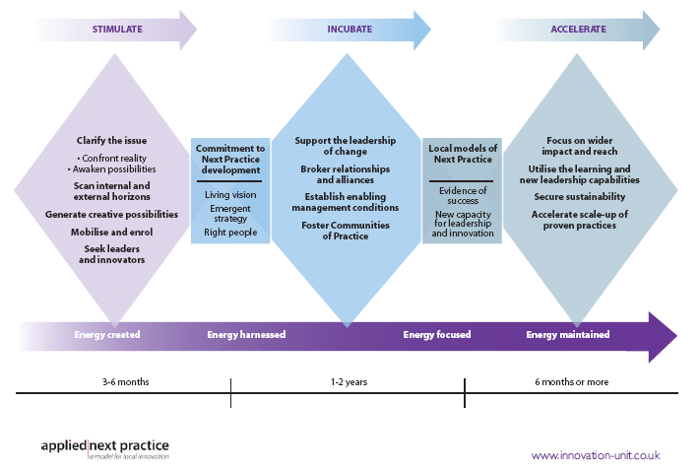
- The IU believes that the BSF programme is the longest lever for transformational change in learning which currently exists, and is keen to extend the range of LAs and localities with which it works.

www.innovation-unit.co.uk

