

Expectations of Transformation

with Building Schools for the Future

The following statement and overview of the scope of expectations of ‘Transformation with Building Schools for the Future’ (BSF) is intended to provide an introduction and to stimulate further consideration for all those preparing for and engaged in the BSF programme.

The BSF programme should make a significant investment in transforming outcomes.

This means using BSF investment to improve the life chances of children and young people by providing 21st century learning, with stimulating environments and facilities that can enable every young person to develop their talents and achieve their very best. This involves a creative and innovative workforce engaged in developing new approaches to learning, teaching and working and making enthusiastic use of new technologies and facilities. This includes forging new relationships with parents, carers, communities and a wide range of partners within, across and beyond schools.

As well as raising aspirations and achievement with young people, BSF developments should make a significant contribution to positioning schools at the heart of their communities in ways that capture the imagination and meet the needs of children, young people, parents, carers, families and the wider community. Central to this will be engaging all stakeholders and making links to wider regeneration imperatives in ways that drive ambition and increase social capital.

Transformation with BSF needs to….
- involve substantial change, not incremental improvement
- be future focused and have long-term objectives
- visualise and define the impact for different client groups
- have high ambition and high expectations
- focus on removing barriers to progress, achievement and life chances
- bring about bold, disciplined and evidence-based innovation

Transformation through BSF should….
- enable the creation of 21st century learners in the context of engaged, connected, vibrant communities, where the school is the centre of learning and the community
- be about pedagogical change that drives ambition and transformation
- create a safe and secure place where learners build their social and learning potential - where inter-generational communities are strengthened and self sustaining
- be about a continuum of learning at all levels for all stakeholders
- be aspirational and take young people and communities beyond their expectations

Outcomes from transformation with BSF will….
- enable all young people to become successful learners, confident individuals and responsible citizens (QCA curriculum aims)
- secure evidence of improved progress and achievement for all young people
- provide increased access, inclusion, equity and excellence
- contribute significantly to developing thriving learning communities in ways that increase social cohesion and regeneration
- provide an environment sensitive to the need for the sustainable use of energy, which inspires innovative thinking about the response to climate change

BSF provides a catalyst for planning transformation across a local area. This will include development of ….
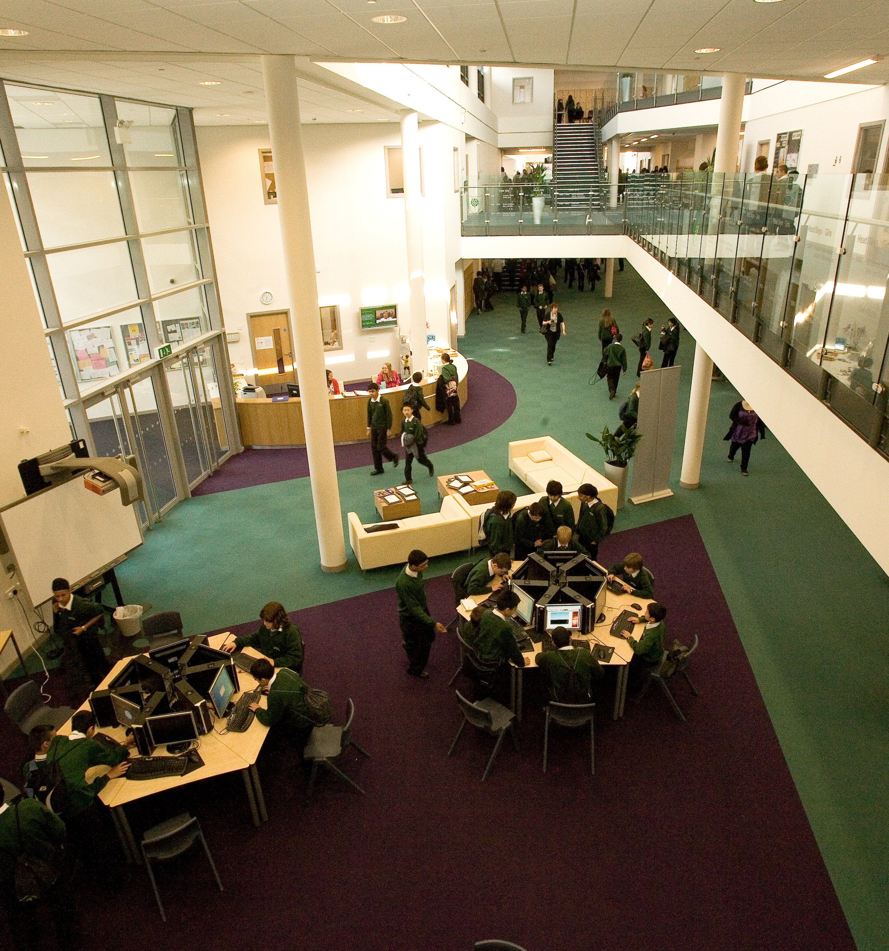
- New thinking and practice
- A local vision and strategy for change
- Joined up major strategies and partnership working
- Responses to student and community priorities
- Innovative learning and environments
- Creative use of new technologies
- Indicators that demonstrate transformed outcomes in relation to the impact on learning and life chances
- Leading learning and changing practice

BSF involves defining features of current and future learning, indicating progress already made and showing the scope and aspiration for further transformation. This could involve taking key learning features and plotting the journey in the context of broad descriptors of past and future practice, as shown in the table:

Achieving transformation for learning and life chances will include. …
- Clarity of vision, values, ethos and strategy
- New models of leadership, governance and partnership
- Further development of workforce reform
- Reconstructed pedagogy
- Wider services, new partners and new relationships with a range of providers
- Broader forms of accountability

This will involve….
- A focus on performance, impact and outcomes
- Imaginative strategies to re-engage disaffected learners and remove barriers to achievement
- Capacity-building, system leadership and succession planning
- Innovative thinking about school organisation, curriculum models and pedagogy
- Introducing new ways of organising learning and using new technologies in physical and virtual spaces that are designed to inspire, engage and motivate every learner
- Meaningful engagement of children & young people, parents and carers, staff, local communities and a wide range of local and national partners
- Connections and alignment of other strategies and resources with BSF through further partnerships and extended, 21st century schools that enable wider education and community transformation, e.g. health, sports, arts, culture, economic regeneration
- Robust and dynamic change leadership, underpinned with a clear change management strategy and planning that supports cultural as well structural change with all stakeholders

Expectations of the impact of transformation can be identified in three categories, outcomes, output and input, expressed as Key Performance Indicators (KPIs), each with a series of measurable proxy indicators

- Outcomes: indicate the impact of the transformation on learning and life chances, e.g. increases in progress and achievement; skills, qualities and competencies; attendance; indicators relating to health and healthy lifestyles, safety, positive behaviour, participation, economic well-being and community regeneration.
- Outputs: indicate expectations of changes in opportunities and practice relating to the strategy for transformation, e.g. learning experiences, curriculum pathways, approaches to teaching and learning; organisation of learning and culture, co-location and joined up services.
- Inputs: indicate new provision that supports changes in opportunities, practice, outcomes and sustainability e.g. design, site and estate; physical and virtual infrastructure; new technologies; extended services; specialist facilities, furniture, equipment and materials.

Some examples of overarching KPIs and types of proxy indicators / targets
Overarching KPIs | Examples of Proxy Indicators / Targets  (measures * : add a numerical value for each baseline, ‘proxy indicator /target and milestone) | Type of Proxy Indicator / Target
High quality youth drop-in facilities on all BSF sites, open in the evenings and weekends, providing more opportunities for young people to be engaged in active citizenship | Demonstrable changes in young people’s behaviour out of hours, as evidenced by fewer police call-outs to school site*, reduced vandalism*, improved perceptions of neighbours* | Outcome
 | Contribution to year-on-year reduction in levels of youth crime and antisocial behaviour* | Outcome
 | Improved records of behaviour*, engagement with school* and progression into work* for young people that are ‘vulnerable or ‘at risk’ | Outcome
 | Evidence of increasing participation in active citizenship activities*, e.g. peer mentoring; volunteering; young people initiating, leading and managing their own activities. | Output
 | More young people benefitting from individual support* / intervention* / mentoring programmes* | Output
 | Increase in youth drop-in facilities*, activities* and access* | Input
 | Resources identified and systems set up to provide more programmes of individual support* / intervention* / mentoring* for young people | Input
High quality fitness facilities and activities that contribute to improved health and fitness | All young people are engaged in 2 + 3 hours of PE and sport per week. | Outcome
 | Improved fitness levels and lower levels of obesity for young people attending secondary schools* and for targeted communities*. | Outcome
 | All schools are contributing to a Schools Sport Partnership and achieve Activemark, Sportsmark or the Sports Partnership Mark. | Input / Outcome
 | Greater number of partnerships with local community sports clubs established* | Output
 | Increasing hours of use* of fitness facilities | Output
 | Increased number* and range of facilities and activities available | Input

