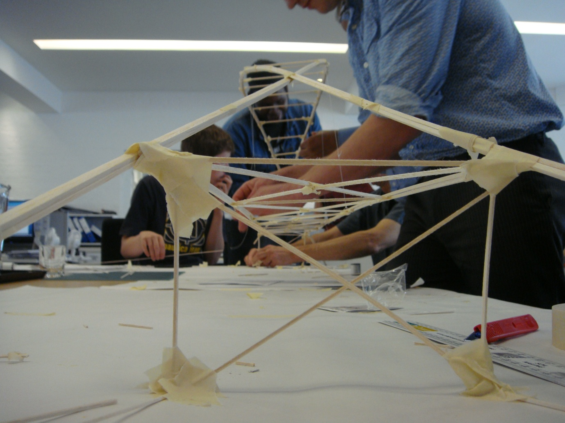

Workshop with Gifford Engineers
The Architecture Foundation
Photographer: Ruby Wright

Offer to BSF and wider schools capital programmes

The Architecture Centre Network

About Us_________________________________________________________

Architecture Centre Network is the development and advocacy organisation for the 23 Architecture Centres in the United Kingdom.

We nurture innovation and good practice by facilitating knowledge sharing; we broker, develop and deliver projects and consultancy with a wide range of stakeholders including government; we advocate for the unique role that architecture and built environment centres can play in improving public engagement with, and the quality of, architecture and the public realm; and we create resources and events to enable architecture centres, and Architecture Centre Network, to promote and maintain excellence.

‘Architecture centres provide exemplary, innovative, and fun educational routes into architecture and the built environment for children and young people. Architecture centres are invaluable members of a team at all stages of the school design and build process, supporting teaching and learning and demystifying the process for all. They are central to the success of any project.’
Peter Karpinski, Head of architecture, and built environment education, DCMS

'The Architecture Centre Network continues to play a pivotal role in nurturing innovation, developing work, and advocating the importance of architecture across the country. With our sustained investments, the organisation has provided invaluable resources and is committed to promoting and maintaining excellence. Ultimately its work stimulates debate, and makes us re-think and re-imagine our built environment and everyday surroundings.'
Moira Sinclair, Executive Director, Arts Council England, London

More information on Architecture Centre Network and a map of the UK centres and link to their websites can be found at www.architecturecentre.net.



Beam, How Places Work, Sheffield
Photographer: Grenville Charles

Architecture Centres and what they can do for you_______________________

Considered world leaders in built environment education, our members are a vibrant group of independent organisations working for the creation of better quality neighbourhoods, buildings and public spaces across the country – and our education teams working for better school buildings and children and young people well informed and vocal about the spaces they live, play and study in.

They achieve this through three common areas of activity, all of which you will find in the BSF process also:

- participation: enabling real public engagement in architecture, the built environment and the public realm
- advocacy: promoting the case for architecture and design of the highest quality
- education: developing greater public understanding of architecture, design and public space

424 education events, 285 information education events, 107 facilitated schools visits to buildings and 32 teacher training days were held across the UK by architecture centres in 2007/08.

Centres actively promote and facilitate public involvement and engagement in the design of quality places and spaces at a local, regional and national level, in formal and informal settings. They have local, sub regional and regional remits in the UK and local knowledge, understanding and established relationships and partnerships.

Centres collaborate and share best practice and knowledge to maximise their reach and effectiveness. Their scale, location and structure may vary but these differences can also be valuable.

With a user-centred focus, nationally, centres can offer:

- artist-led schools projects and commissions
- Arts Award assessment
- creative and cultural learning to meet Every Child Matters agenda
- cross-circular learning
- Design Leadership Training for Local Authorities
- Design Quality Indicators for Schools questions cards
- Design Review
- Key Stage and Diploma focused teaching and learning
- LOTC facilitation - site visits and guides on how buildings work
- Placemaking activity
- schools grounds and landscaping design award scheme
- Spaceshaper 9-14 workshop delivery
- sustained youth engagement in architecture outside of school activities
- teacher continuing professional development
- teaching resources and schemes of work

and will:

- deliver the sustainability agenda
- develop children and young people as an expert client group and design advocates
- develop regeneration awareness
- development all stakeholders understanding of the design and build process
- place architects in residence in schools
- sit on expert client groups
- train artists and built environment professionals in working with schools and young people

The Network facilitates joined up and cross sector working, knowledge exchange and collaboration – our impact collectively is our greatest strength – and whilst all centres can work with all stakeholders in the BSF process in all of its stages those listed below specialise in BSF teaching and learning activity.

If you can’t find a centre in your area, or if your nearest centre isn’t listed here, centres work collaboratively across regions so you will never be without the opportunity to benefit from our exemplar activity.



Legacy Now Youth Panel Discussion
Fundamental
Photographer: Amy Scaife
Architecture Centres _______________________________________________

Arc (Hull and region)

Go Architecture takes the form of quarterly workshop sessions providing learning providers with design training and collaborative project ideas for education establishments and community learning. The sessions will be particularly relevant to staff delivering Art, Design and Technology, Geography, History and the Construction and Built Environment Diploma, but all are welcome.

Go Architecture can also be tailored for schools and BSF projects:

Go Architecture: Live
- using the existing school as a live project (pupil-led), inc. guest speaker/s to inspire and inform about architecture
- involve Planning Committee Members in the process
- taking pupils and Planning Committee Members to visit an exemplar building/area
- working with schools to explore and analyse their existing environment
- bringing in a professional to work with them

Go Architecture: Networking
- days for professionals working within education, teachers, SLTs and Elected Members to come together to share their experiences and best practice

- advice on how to engage pupils and the whole school in design awareness
- guest speakers to address issues around BSF, design, the built environment and public art

Public Art Advisory Service
- Expert support and management in bringing public art to the school environment
Embedding creativity and culture in the life of the school.

For information and contact details please visit www.arc-online.co.uk

Architecture Centre Devon and Cornwall (Plymouth and counties) aims to raise public awareness of design issues, and support local authorities, communities and practitioners in the creation of high quality design. We provide inclusive and inspiring learning opportunities for all to facilitate understanding of, and engagement with the built environment.

Services include:
- creation of opportunities for young people to be involved in improving the design quality of their school buildings
- providing educational visits to inspirational buildings or developments, promoting design literacy and the value of good design.
- delivering tailored educational activities, including outreach workshops and site visits according to schools’ needs
- facilitating design workshops
- facilitating community consultation events
- providing support and advice for local schools on new buildings, including BSF and the Primary Capital Programme
- ‘Critical Friend’ advice and guidance for local authorities and client groups on design review and project enabling
- development and dissemination of inclusive resources for young people which are relevant and complement the National Curriculum
- work in support of the Cultural Offer and Every Child Matters initiatives
- co-ordinating architectural exhibitions

For information and contact details please visit www.acdandc.org.uk

The Architecture Centre, Bristol, championing better buildings and places for people in the South West.

Services include:
- BSF and PCP visioning support and workshops
- inspirational educational visits to exemplar buildings
- exciting programmes of stakeholder engagement for school communities being redesigned delivered by experience staff
- online case studies and resources on sustainable school design
- Spaceshaper 9-14 workshop delivery (key development partner for this new CABE toolkit) to explore school landscaping, community play spaces and public realm
- Design Quality Indicator workshops for schools (developed by Kent Architecture Centre)
- Design Review Panel events for young people

- built environment summer schools for young people involved in the development of new buildings and spaces
- workshop delivery and resource development to support the new Construction and Built Environment Diploma for 14-19 year olds
- built environment sector careers information and advice
- teacher CPD on themes of architecture and design
- development of curriculum linked teaching resources exploring the built environment
- Design Leadership Training for Local Authorities
- events programme incorporating talks, debates, gallery tours, walks and visits
- exhibition programme centred around the themes of architecture, design, built environment and public art
- Public information area of resources and publications

For information and contact details please visit www.architecturecentre.co.uk.

Beam (Wakefield and region)

Beam offers a range of practical and creative activities for the whole school community – young people, teachers, governors and parents - as they consider the creation of environments to support learning in the 21st Century. We also have an innovative programme that helps teachers make use of the built environment as an exciting and effective cross-curricular learning resource.

We have worked with schools from across the Yorkshire region, but in particular as part of the BSF processes in Sheffield and Barnsley.

As part of Barnsley's ambitious Re-Making Learning Programme, the Priory Sports College and Willowgarth High School will shortly merge and have a new school building. While Re-Making Learning is about more than new school buildings, and intends to transform the borough's approach to learning, it is our view that the design of those new schools will play an important part in what takes place within them. Our work with the two schools resulted in a sketchbook of ideas for the new school that was passed on to the design architects.

In Sheffield, Beam has worked with the consortium to build and refurbish schools across the city to ensure good quality public art was integrated into the schools emerging from the first stage of the programme. An international competition led to artists working with students to produce works that reflected the character and identity of the whole community of users.

Wakefield is about to join the BSF programme and Beam is working closely with Children’s Services to develop a programme that will support the school community, with work commencing shortly in the Airedale area of the district.

Beam has been awarded the Learning Outside the Classroom quality badge.

For information and contact details please visit www.beam.uk.net.

The Building Exploratory (Hackney and East London)
The Building Exploratory’s learning programmes aim to motivate, inspire and engage a wide range of learners. Our creative approach to cross-curricular built environment education supports schools in

meeting the cultural entitlement agenda and producing successful learners, confident individuals and responsible citizens.

High quality programmes offer alternative learning settings, which provide focus within and between National Curriculum subjects, and foster the development of the following skills in students:

- critical thinking and problem solving
- collaboration, decision making and communication
- creative thinking and practical making
- speaking and listening
- observation and investigation
- visual literacy and spatial awareness
- literacy and numeracy
Services include:

- cross curricular education programme for primary and secondary schools, including exhibition based and in-school workshops
- career days and site visits for secondary school, college and diploma students
- school site focussed transition projects for Year 6 students to support moving to new secondary school
- INSET training for teachers including bespoke sessions supporting use of the school site as a learning tool
- walking tours, outreach sessions and workshops exploring how buildings are made and places are shaped
- holiday and extended school activities
- lifelong learning programmes providing intergenerational learning opportunities for schools
- training for artists and Built Environment professionals in working with schools and young people
- online learning resources supporting understanding of the local area including Brickfields, Places of Worship, Treasures, Memory Blitz and Portico Interactive
- artist led school and community projects and public art commissions such as hoarding art works and ‘Treasures’ audio posts
- family learning projects and participatory arts workshops
- community engagement and place making projects, including heritage focus, in partnership with cultural organisations, artists and facilitators and the private sector
- volunteer programme including young volunteers

For information and contact details please visit www.buildingexploratory.org.uk.

Concourse (Leeds)
For information and contact details please visit www.concourse.org.uk.

Cube (Manchester)
For information and contact details please visit www.cube.org.uk.

Fundamental Architectural Inclusion (Newham and East London) seeks new ways for people to genuinely participate in the planning and development process in their communities.

Fundamental has an in-house team of research associates and offers bespoke hands-on workshops to engage and consult the whole school community and other key stakeholders in BSF developments and produce comprehensive reports for a variety of audiences – statutory, funders, children and young people, detailing the outcomes of the consultation.

Fundamental can develop specialist education resources to support the BSF programme. For example, we are currently developing resources to support two units of the Construction and Built Environment Diploma linked to the Olympic Aquatics Centre and have developed a national online resource Bringing the Games Home! to support 2012 learning for Key Stage 2 and 3.

Fundamental has expertise devising and managing Youth Panel programmes linked to specific development opportunities and runs the Legacy Youth Panel on behalf of the Olympic Park Legacy Company. The Panel is a dedicated group of young people from the five Olympic host boroughs who come together on a regular basis to inform the Olympic Legacy Masterplan and act as an influential lobby group.

We also support a youth-led approach to engagement in the built environment. The Architecture Crew was established in LB Newham in 2004 and offers a vibrant programme of community engagement in regeneration. The Crew are currently running a project to design part of the new Lea River Park in East London with the London Thames Gateway Development Corporation.
Fundamental offers an innovative package of professional development opportunities for teachers, arts practitioners youth providers and young leaders which address an identified knowledge and skills gap in the built environment sector.

Fundamental has expertise devising and delivering creative, participatory events such as Give and Take and It’s our time, look to the future, look East! which are specifically designed to bring together groups of people to explore specific developments opportunities for themselves.

For information and contact details please visit www.fundamental.uk.net.

Kent Architecture Centre (Chatham and south east region)

- Organise and facilitate Building Visit for School Stakeholder group to prepare for participation in DQI Briefing Workshop- can be whole or half day- makes use of the DESC question cards.

- Organise and facilitate DQI Briefing Workshop for School Stakeholder group

- Run workshops for teachers and/or students using the DESC question cards to look at their existing building so that they can contribute to the development of the Brief for new/extended school building project.

- Design Review for assessment at both brief and outline design stages- independent, informed critique to help design team and client make the most of the capital build opportunity.

For information and contact details please visit www.architecturecentre.org.

MADE* (Birmingham and Midlands)

MADE* uses the built environment as a learning resource, holds a Learning Outside the Classroom Quality Badge, and was recently shortlisted for a Homes and Communities Agency Academy Award for ‘Investing in Young People’ . We bring together residents, young people, architects and artists as equal partners to make sure that local people have a real influence over the design of their own neighbourhoods and schools, running bespoke projects with students and teachers which link to the curriculum and extended learning.

MADE’s offer includes:
- bespoke projects linked to the curriculum, change management and learning outcomes
- setting up student-led design teams
- access to built environment professionals (architects, landscape architects, civil engineers)
- creative input, such as through artists
- student-led recruitment panels to select practitioners
- links to regeneration projects beyond the school gates and partnerships with external organisations
- DQI assessements
- design competitions
- ideas for using outdoor spaces
- links to Sustainable Schools / Eco Schools
- supporting students to monitor against their own learning outcomes
- publication of case studies
- encouraging students to carry out dissemination, such as through blogs and conferences
- community engagement
- guidance on design issues and design review
- study tours

For information and contact details please visit www.made.org.uk

Northern Architecture (Newcastle and north east)

Northern Architecture works to extend knowledge and support to local authority BSF teams, pupils, teachers and community and architects/designers involved.

It encourages creative participation to empower professionals to use creative tools to encourage creative participation and involves up and coming designers using skills of newly qualified and qualifying architects and designers as part of their learning, supported by resources and new teaching tools linked the curriculum.

Northern Architecture acts as a connection between school, local authority and designers, brokering relationships and ‘joined up’ work and encourages peer-led education, involving pupil engagement and problem solving.

It offers a n introduction to the design process, feeding back into the core curriculum subject – ICT, DT and Art and Design and all work and ideas created by the stakeholders are fed back to the design decision makers through a variety of evaluative means. Northern Architecture also offers creative professional development, empowering schools management team and stakeholders through creative work.

From one day workshops to bespoke projects, Northern Architecture can offer a range of activities which respond to a school’s phase or level of BSF status.

Case study: Launching a Future School

250 Stockton school children have recently taken part in a groundbreaking education project as part of ambitious plans for a new school building.

Ian Ramsey School, Stockton, has been working towards designs for a new building as part of Building Schools for the Future and has been keen to involve the children in the design process. Designing and building a new school is a significant event with the potential to have a huge impact on the staff and pupils. As they are the clients – the people who will be using the building – the school management team felt strongly that they should be involved in the process in some way.

The creatively driven participation project was been designed and delivered by Northern Architecture, the Architecture Centre for the Northern Region, to engage the school’s year eight pupils in the design process through English, Maths and ICT. This project provided a creative platform from which the children can express their opinions and aspirations for the new school.

Emma Kench, Education Officer, Northern Architecture said “Building Schools for the Future is an enormously wide-reaching programme of development work in schools across the country. At Northern Architecture, we believe that creating opportunities for education, consultation and participation for those who will use buildings and spaces is an essential and positive step towards achieving good design. The staff and the pupils have shown an abundance of enthusiasm and support for the project.’

By learning some of the skills needed to be an architect, visiting and learning about exceptional learning spaces and working with professional practitioners within the build environment, the children made work ranging from poetry to architectural models and landscape designs to digital designs over 6 weeks evidencing their creativity and understanding of the design journey towards a new school building.

The first stage of the project culminated in a public exhibition of work at Ian Ramsey School which was open to the local community, local authority members, teachers and prospective designers and architects. This project is about to enter the second phase, providing scope for reflective learning while developing the pupils’ work further as part of the live design process.
For information and contact details please visit www.northernarchitecture.com.

Open House (London-wide festival)

All Open House programmes are developed and delivered using a team-based approach that draws on our expertise in culture, creativity and education. To date our education programmes have inspired over 22,000 students and more than 5,000 teachers.

Open House is supporting both professionals and schools involved in the BSF programme through:
- professional guidance, networking and training for local authorities, planning councillors, school stakeholders and BSF teams

- School Exemplar building explorations for architects, teachers, school governors, councillors and BSF professionals, enabling participants to explore in depth how good school design underpins effective learning, via live site explorations, seminars and presentations.
- Architecture in London schools, involving over 2000 students per year, bringing architects into the classroom, architecture into the curriculum and students into contact with contemporary design.
- regular programme of cultural events, including: debates, tours, talks and special events encouraging everyone to explore and understand the value of architecture
- online resource centre for toolkits, manuals and exemplar case studies including how to engage young people through architectural design.
- training evenings for teachers and architects on architecture and education.
- Young Planners youth training programme, training young Londoners to inform decisions around the design of schools and the built environment in their local borough.
- unique campaigns such as My City Too, enabling 12–19 year olds across London boroughs to voice their ideas, aspirations and solutions for the capital’s spaces and places.
- Our Learning by Design publications, showcasing exemplary school buildings, have inspired school stakeholders nationwide.

For information and contact details please visit www.openhouse.org.uk.

Opun (Nottingham and Midlands)
For information and contact details please visit www.regenerationem.co.uk.

Places Matter! (Liverpool)

- Design advice - Very experienced Design Review service
- Enabling service - Network of design professionals that can provide advice and support, including engaging pupils
- Teacher training programmes that link to the core curriculum, in particular teachers of the Construction and Built Environment Diploma, which could be tailored to teachers in BSF schools to enable them to engage more successfully the pupils
- Education work - Places Matter! could discuss with any LA the potential of developing a programme of activity that responds to their needs. (We do not have a standard programme for BSF)
- Skills programme - training for local authority staff and design professionals to improve the quality of the built environment in the region
- Research - including the Economic Value of Good Design

For information and contact details please visit www.placesmatter.co.uk.

RIBA Trust (London)
For information and contact details please visit www.riba.org.

Shape East (Cambridge)
For information and contact details please visit www.shape-east.org.uk.

The Shed (South Yorkshire)

The Shed is a brand new architecture centre working with schools, young people, communities and the public in enabling them to become more confident in participating in the shaping of their own places and spaces.

For information and contact details please visit www.theshed-sydc.org.uk.

Solent Centre for Architecture + Design (Solent and wider counties region)

SCA+D aims to promote high quality design in the built environment, with an emphasis on achieving environmental and social sustainability.

It’s comprehensive education programme includes workshops for schools with an emphasis on teacher CPD, delivering intensive teacher training workshops on Built Environment, Sustainability, Landscape and Public Art and Placemaking, all supported by an extensive online resource library.

Other education and stakeholder services include:
- a series of training workshops for Initial Teacher Training students
- built environment workshops and teacher training programme tailored to individual schools and colleges – including BSF workshops and study tours
- community consultation
- community events and resources such as City Vision Southampton (physical and digital interactive models) and Hidden Histories which aim to involve as many people as possible in the designed environment that surrounds them
- Design Advocacy
- design awards
- design training and study tours programme for local authority officers and councillors
- exhibitions, events and design competitions
- Grounds for Optimism, a secondary schools landscape award programme due to launch nationally in 2010/11
- resources, including Where We Live: A Guide to Urban Design
- Spaceshaper, Young Spaceshaper and Arts Award assessment (to Bronzer and Silver levels)
- SPUD, a network of youth groups across our region focusing on live design briefs with the local authorities and working alongside professional architects
- Take One Building, a new programme of online interactive investigation and interrogation of buildings for young people
- working alongside artists in the built environment and interdisciplinary collaborations

For information and contact details please visit www.solentcentre.org.uk.

Transform MKSM (Milton Keynes)
For information and contact details please visit www.transformmksm.co.uk.

Urban Vision North Staffordshire (Stoke on Trent and urban region) works with partners to promote high quality architecture and urban design in and around the North Staffordshire conurbation to:

- bring about successful, physical and economic regeneration and social inclusion
- create a better and more sustainable urban environment
- improve the image of the area
- raise the quality of life for the citizens of today and tomorrow

Services that we offer include:

- design, implementation and management of creative built environment education workshops and projects

- access to a network of creative practitioners and built environment professionals
- design review panel (observer opportunities)
- mini Design Review sessions
- creative consultation
- community engagement
- educational tours and visits
- Spaceshaper 9-14 facilitation
- small library of books and magazines relating to built environment
- exhibition space
- workshop and meeting/event space

For information and contact details please visit www.uvns.org.

