

PfS Contractors’ Framework
Sector Map

Document Status: Issued

November 2009

Document Control
PfS and its advisers accept no liability whatsoever for any expense, liability, loss, claim or proceedings arising from reliance placed upon this Guidance Document – Contractors Framework Sector Map

Document Properties
Document Owner | Academies Director
Organisation | Partnerships for Schools
Title | PfS Contractors’ Framework Sector Map
Abstract
The PfS Contractors’ Framework Sector Map provides Framework Users with an indication of the Sector in which they are located with regard to the use of the PfS Contractors’ Framework

Version History
Date | Editor | Version | Status | Reason for change
09 Nov 2009 | DO | 1.0 | Issued | First issue for PfS Contractors Framework

Pfs contractors’ Framework sector map
Introduction
The attached map provides Framework Users with an indication of the Sector in which they are located with regard to the use of the PfS Contractors’ Framework. There are 2 Sectors:
- Sector North (shown as Sector 1 in Map) – This comprises the North West, the North East, Yorkshire and the Humber, the East Midlands, and the West Midlands;
- Sector South (shown as Sector 2 in Map – This comprises the East of England, the South East, the South West, and London.
In the event of any query, Framework Users are advised to contact the PfS Project Director.
The following Contractors have been appointed to the PfS Contractors’ Framework Panel in the respective Sectors:
Sector North Sector South
 | Contractor |  | Contractor
1 | Balfour Beatty Construction Limited |  | Apollo Property Services Limited
2 | BAM Construction Limited |  | Balfour Beatty Construction Limited
3 | Bovis Lend Lease Limited |  | BAM Construction Limited
4 | Carillion Construction Limited |  | Bovis Lend Lease Limited
5 | Clugston Construction Limited |  | Carillion Construction Limited
6 | Interserve Projects Services Limited |  | Interserve Projects Services Limited
7 | Kier Regional Limited |  | JB Leadbitter & Co Limited
8 | Shepherd Construction Limited |  | Kier Regional Limited
9 | Sir Robert McAlpine Limited |  | Rydon Group Limited
10 | VINCI Construction Limited |  | Sir Robert McAlpine Limited
11 | Wates Construction Limited |  | Wates Construction Limited
12 | Willmott Dixon Construction Limited |  | Willmott Dixon Construction Limited

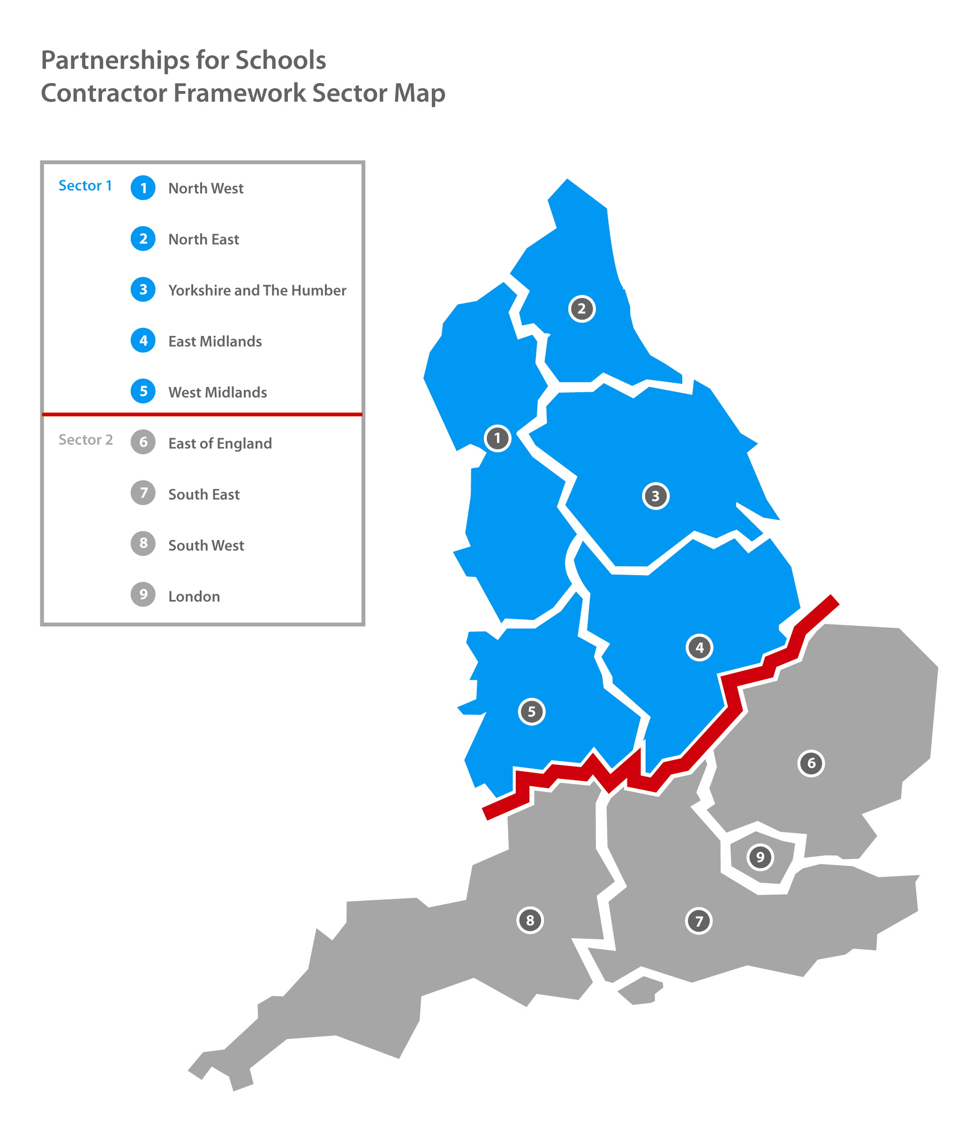
Partnerships for Schools - Indicative list of locations by Sector / Sub-Region
Sector 1 (North)
1. North West
- Cumbria
- Lancashire
- Cheshire
- Sefton
- Wirral
- Liverpool
- Knowsley
- St Helens
- Wigan
- Bolton
- Bury
- Rochdale
- Oldham
- Salford
- Trafford
- Manchester
- Stockport
- Tameside
- Blackpool
- Halton
- Warrington
- Blackburn with Darwen

2. North East
- Northumberland
- Durham
- Newcastle upon Tyne
- Gateshead
- North Tyneside
- South Tyneside
- Sunderland
- Hartlepool
- Darlington
- Stockton-on-Tees
- Middlesbrough
- Redcar & Cleveland

3. Yorkshire and The Humber
- North Yorkshire
- Leeds
- Barnsley
- York
- Doncaster
- East Riding of Yorkshire
- Bradford
- Caldergate
- Kirklees
- Sheffield
- Rotherham
- Kingston upon Hull
- North Lincolnshire
- North East Lincolnshire

4. East Midlands
- Lincolnshire
- Nottinghamshire
- Derbyshire
- Leicestershire
- Rutland
- Northamptonshire
- Derby
- Nottingham
- Leicester

5. West Midlands

- Staffordshire
- Shropshire
- Herefordshire
- Worcestershire
- Warwickshire
- Wolverhampton
- Dudley
- Walsall
- Sandwell
- Birmingham
- Solihull
- Coventry
- Stoke
- Telford and Wrekin

Sector 2 (South)
6. East of England
- Norfolk
- Cambridgeshire
- Hertfordshire
- Suffolk
- Essex
- Peterborough
- Bedfordshire
- Luton
- Thurrock
- Southend on Sea

7. South East
- Oxfordshire
- Hampshire
- Buckinghamshire
- Surrey
- West Sussex
- East Sussex
- Newbury
- Reading
- Wokingham
- Bracknell & Forest
- Windsor & Maidenhead
- Slough
- Isle of Wight
- Southampton
- Portsmouth
- Brighton & Hove
- Medway Towns
- Milton Keynes

8. South West
- Gloucestershire
- Wiltshire
- Somerset
- Devon
- Dorset
- Cornwall
- South Gloucestershire
- Bristol
- Bath & NE Somerset
- North Somerset
- Plymouth
- Torbay
- Poole
- Bournemouth
- Swindon

9. London
- Barking & Dagenham
- Barnet
- Bexley
- Brent
- Bromley
- Camden
- City of London
- City of Westminster
- Croydon
- Ealing
- Enfield
- Greenwich
- Hackney
- Hammersmith & Fulham
- Haringey
- Harrow
- Having
- Hillingdon
- Hounslow
- Islington
- Kingston & Chelsea
- Kingston upon Thames
- Lambeth
- Lewisham
- Merton
- Newham
- Redbridge
- Richmond upon Thames
- Southwark
- Tower Hamlets
- Waltham Forest
- Wandsworth

