

Delivering Academy Building through PfS

Guidance Document

The ICT Strategic Integration Group

PfS and its advisers accept no liability whatsoever for any expense, liability, loss, claim or proceedings arising from reliance placed upon this ICT Strategic Integration Group Guidance Note.

Document Properties
Document Owner | Academies Director
Organisation | Partnerships for Schools
Title | Delivering Academy Buildings through PfS  Guidance Document  The ICT Strategic Integration Group
Abstract
This guidance document describes the role, function and responsibilities of the ICT Strategic Integration Group within the two delivery structures for Academy Buildings;
- the PfS Contractors Framework; and
- the Local Education Partnerships (LEP) in the Building Schools for the Future (BSF) programme.
This guidance document also describes the role of the different external ICT Advisors involved in Academy projects and the arrangements for fees and funding for the different procurement scenarios.

Version History
Date | Editor | Version | Status | Reason for change
30 Oct 2008 | KN | 2.0 | Final | Amendments to section 4.2.  Final Version for Publishing
22 Jun 2010 | KN | 3.0 | Final | General amendments for PfS Contractors Framework & changes to DfE and Becta

Contents

1.0 Introduction 1
2.0 The ICT Strategic Integration Group 1
3.0 Individual Roles and Responsibilities 7
4.0 External Advisors 9
5.0 Funding 12
6.0 ICT and Design Development Process 13

1.0 Introduction

  - Purpose of this Guidance Document

The purpose of this guidance document is to describe the role, function and responsibilities of the ICT Strategic Integration Group within the two delivery structures for Academy Buildings;

- the PfS Contractors Framework; and

- the Local Education Partnerships (LEP) in the Building Schools for the Future (BSF) programme.

This guidance document also sets out the roles and responsibilities of the various external ICT Advisors involved in Academy projects and the arrangements for fees and funding for the various procurement scenarios.

It should be noted that this document has been produced for all situations where academy buildings are being procured through the PfS Contractors Framework.

The guidance is intended for use by LAs and Academy Sponsors/Trusts.

2.0 The ICT Strategic Integration Group

  - The Purpose and Role of the ICT Strategic Integration Group

A number of groups will be established soon after an Academy enters the feasibility phase of its development including the Project Steering Group and the Design Group. There is a need for Local Authorities and Sponsors/Academy Trusts to demonstrate that they are managing the process of integration between the building design and ICT design/implementation. The management of this interface is one of the top 10 risks to Academy projects and demonstrating that an active and effective integration strategy is in place to mitigate against this risk is a core requirement of the OBC and FBC approvals process. One method for demonstrating that an active and effective integration strategy is in place is to establish an ICT Strategic Integration Group. The ICT Strategic Integration Group should act as a sub-group to the Design Group to oversee the development of the ICT strategy from Vision to Implementation and manage important interfaces between the Academy and local BSF programmes (where applicable), as well as the critical interface between the ICT Provider and Design and Build Contractor. The ICT Strategic Integration Group should be established soon after the Academy Project enters the feasibility phase at the same time as the Design Group and is expected to be in place until the building is handed over to the Academy Trust.

The purpose of the ICT Strategic Integration Group is:

- As guardian of the Sponsor’s ICT Vision for the Academy;
- To implement a programme of work that ensures key outputs are available for the procurement, design development, construction and commissioning stages of the scheme(s);
- To develop and review the ICT Risk Register and Risk Management strategy;
- To develop and agree an ICT Responsibility Matrix for the design, construction and commissioning stages of the scheme;
- To monitor the overall programme for the scheme, with a particular focus on the procurement of the ICT provider, production of key information for the design and construction stages, access requirements during the construction phase for the ICT Provider, CPD requirements at central & scheme levels and handover/commissioning requirements;
- To ensure that the ICT proposals, including project scope and cost models, are aligned between the Academy and the BSF Managed Service (where applicable);
- To consider the impact of any existing initiatives such as the procurement of an area wide Learning Platform, Computers for Pupils, Home Access scheme, etc.;
- To consider and agree the degree of integration between core building and information systems (e.g. MIS, Building Management System, CCTV, Access Control, etc.);
- To provide an informal forum for resolving any disputes between the specific Academy and the local BSF programme, where applicable;
- To provide an informal forum for resolving any disputes between the Selected Panel Member (Design & Build Contractor) and the ICT Provider
Note: Any contractual commitments take precedence over the functions of this group
- To contribute to the discussions on development and implementation of interim services at the Academy (where applicable) and monitor any implications for the overall scheme;
- To contribute to the evaluation process for the Design & Build Contractor and the ICT Provider, prior to appointment (where applicable);
- To contribute to the design development process by providing information and comment on ICT design and integration issues;
- To report on progress to the Design User Group;
- To report on progress to any applicable BSF ICT Strategy Groups or Local Authority ICT Strategy Groups

It should be noted that where Academies are to be wholly procured (Buildings and ICT) through a LEP in a BSF programme, the work plan for the ICT Strategic Integration Group must fit with the local BSF programme in order that they are entirely aligned through the BSF Strategy for Change (SfC)/Outline Business Case (OBC)/Final Business Case (FBC) process. In this case, the Academy is treated in the same manner as other BSF schools within the scope of the procurement and is expected to be fully involved in the BSF ICT Strategy Groups. In these circumstances, the Academy projects may decide that the functions of the ICT SIG are adequately covered by the BSF delivery structures. Alternatively, the Academy projects may decide to establish an ICT SIG with a modified scope to suit their circumstances.

For all other circumstances and where academy buildings are procured via the PfS Contractors Framework, the processes and structures set out in this guidance note will fully apply.

2.2 The Structure and Organisation of the ICT Strategic Integration Group

PfS Contractors Framework

The structure of the ICT Strategic Integration Group in relation to the overall project structure is shown below for Academies delivered through the PfS Contractors Framework:

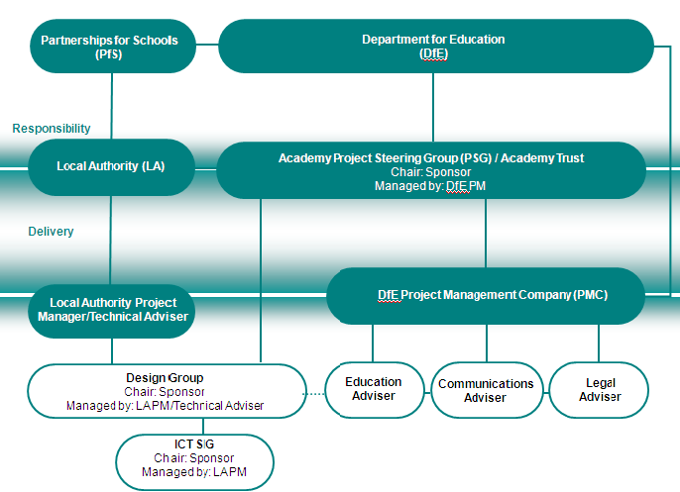

Figure 2.1: Project Organisation for Academies delivered through the PfS Contractors Framework

It is expected that the ICT Strategic Integration Group will report directly into the Design Group on all ICT matters.

BSF

For Academies delivered through the BSF Programme the likely relationship to the LA BSF project is shown below:

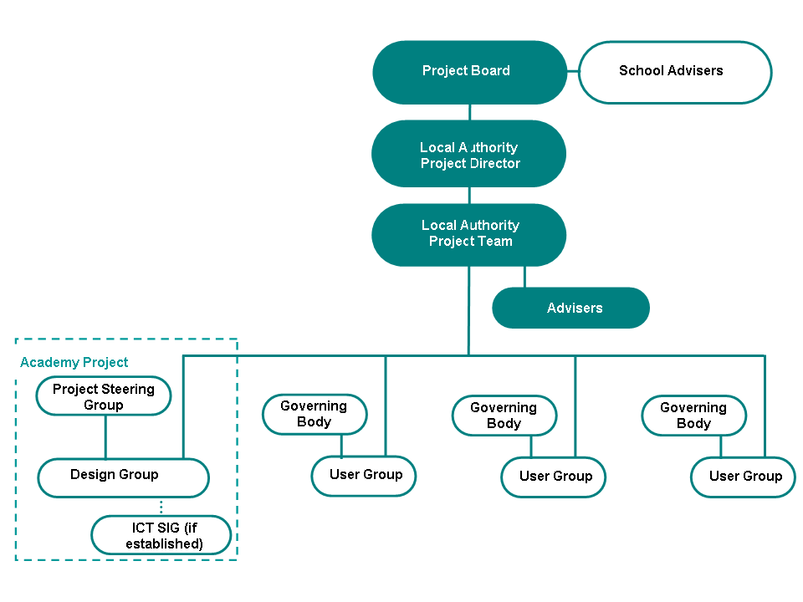
(or NF but within a BSF area)
(outside a BSF area)
Figure 2.2: Project Organisation for Academies delivered through a LEP

2.3 Membership of the ICT Strategic Integration Group

The initial members of the ICT Strategic Integration Group should be selected once the Academy has entered Feasibility. The Sponsor/Trust and the LA should agree the members of the ICT Strategic Integration Group and further members may be added as required, by agreement between the LA and Sponsor. It should be noted that the ICT SIG is expected to be a working forum, hence some background knowledge of ICT issues will be an advantage for members

The members of the ICT Strategic Integration Group will typically include:

- Academy Sponsor or their representative (Chair);
- The Academy ICT Advisor (where applicable)
- The LA Project Manager (Day to day management);
- The LA ICT Advisor
- The LA BSF ICT Advisor (where applicable)
- Principal or Principal Designate (where applicable)
- Academy Sponsor/Trust Representatives;
- PfS Academies/BSF Project Director (where applicable)
- ICT Provider (when available)
- Selected Panel Member/Design & Build Contractor (when available)

It is recommended that, for the ICT Strategic Integration Group to function as an effective working group, the membership should be limited to only 1 key representative from the above functions. The ICT Strategic Integration Group members should be parties that have a direct interest and responsibility for the ICT strategy, implementation process and/or subsequent operation of the Academy. Members of the ICT Strategic Integration Group need to be persons who have a broad working knowledge of ICT issues, are able to give the appropriate amount of time input into the design and construction process and also who will ideally be available for the life of the project to ensure continuity.

It will be the responsibility of the LA and the Sponsor/Trust to ensure there is sufficient representation and expertise on the ICT Strategic Integration Group for it to undertake its role and responsibilities effectively and efficiently.

Academy Sponsor/Trust Representatives

The Sponsor/Trust will need to have a representative or representatives on the ICT Strategic Integration Group that are able to articulate the Academy’s ICT Vision and implementation strategy to the various members of the ICT SIG, in particular to the ICT Provider and Design Team(s) both at the bidding stage and during implementation. The Sponsor should have representatives that fully understand the educational ethos and vision of the Academy and, if possible, have a broad working knowledge of ICT issues and/or construction projects. The Sponsor/Trust may choose to have their ICT Advisor, where applicable, on the ICT Strategic Integration Group to assist them.

Principal Designate

When the Principal/Principal Designate for the Academy has been appointed, they may sit on the ICT Strategic Integration Group or delegate this to another appropriate senior member of staff.

Other Parties

At various times in the life of the project, the ICT Strategic Integration Group may decide that they would like other parties/consultees to input during the design and implementation process but not be full members of the Group, such as specialist input on a particular design or educational issue (e.g. AV specialists, cashless catering, etc.). The Local Authority, Sponsor/Trust, ICT Provider and Design & Build Contractor are encouraged to seek additional specialist input beyond that on the Group, where possible, to broaden the knowledge and experience that can be brought to the scheme and in order to be in a position to provide detailed and timely responses during the design development phase of the project.

Such additional input outside the core ICT Strategic Integration Group members should be agreed by the members of the Group and their input should be organised by the relevant group member.

2.4 Chairmanship/Management of the ICT Strategic Integration Group

It is anticipated that the ICT Strategic Integration Group will be chaired by the Sponsor/Trust, which is consistent with the running of the Design Group and the funding mechanism for ICT Hardware. The day to day management of the ICT Strategic Integration Group will be the responsibility of the Project Manager appointed by the LA to manage the procurement of the PfS Contractors Framework Panel Member or the LEP. The LA Project Manager will be responsible for organising all ICT Strategic Integration Group meetings, attendance, taking minutes, ensuring agreement of decisions, chasing of actions etc.

2.5 ICT Strategic Integration Group Meetings

The frequency of meetings is to be agreed by the members of the ICT Strategic Integration Group. Throughout the life of the building project it is recommended that the ICT Strategic Integration Group meet on a monthly or 6-weekly basis as follows:

- Prior to the Design User Group/Design Group where the Academy is procured though the PfS Contractors Framework

- Prior to the BSF Board meetings and BSF ICT Strategy Group meetings where the Academy is procured through the LEP,

This is to ensure that up to date reporting can be fed into the Design Group, PSG and BSF Board meetings.

Consultation sessions may take place on a more frequent basis (weekly or fortnightly), dependent on the stage of design and procurement. However these meetings will not necessarily require attendance from all the core ICT Strategic Integration Group members depending on the stage of design development and the issue being consulted upon. It will be for the LA Project Manager to establish, with the agreement of all ICT Strategic Integration Group members, who should attend which meetings. However it is imperative that the core members of the Group attend regular working meetings to establish the ICT project scope, functional specifications, risk management strategy, detailed programme, systems integration strategy and interface protocol.

All meetings are to be organised by the LA Project Manager.

2.6 Partnering Approach and Conflict Resolution

It is expected that members of the ICT Strategic Integration Group will work in a collaborative manner throughout the life of the project. Members of the ICT Strategic Integration Group should establish a charter at the commencement of the operation of the Group that sets out the principles of collaborative working that all parties will adhere to and also set out the structure of the group in relation to other existing forums, such as BSF ICT Strategy Groups, collaborative groups of schools (e.g. learning networks) or other Local Authority groups.

If areas of potential conflict or difficulty arise, it will be the responsibility of the LA and Sponsor to work together in partnership to resolve these. In cases where difficulty or conflict arises between the ICT Provider and the Design and Build Contractor, the parties will be expected to work together in partnership to resolve these issues within the auspices of the Group. It should be noted that all contractual obligations take precedence over the functions of the Group with respect to resolving disputes in a formal manner.

Where conflicts or difficulties cannot be resolved between the LA and Sponsor in relation to ICT issues, these should be escalated to the DfE Academy Project Lead and the PfS Project Director to seek an appropriate resolution.

If there are instances of non-performance by any member of the ICT Strategic Integration Group this is to be reported to the DFE Project Lead and the PfS Project Director for resolution via the PSG and to escalate further if necessary.

- Individual Roles and Responsibilities

Academy Sponsor/Trust (with support from the DfE appointed PMC, where appropriate)

The roles and responsibilities of the Academy Sponsor/Trust include:

- Develop the ICT Education Vision
- Participate in the appointment of an ICT Technical Advisor (where appropriate)
- Input into the development of key documents such as the output specification and functional specifications
- Input on transitional arrangements and development of interim services within the Academy (where appropriate)
- Chair the ICT Strategic Integration Group
- Agree with the LA the membership of the ICT SIG
- If appropriate, assist in the selection of the ICT Provider or LEP
- Participate in consultation/briefing sessions, as required
- Participate in the ICT design development process during the pre-procurement, procurement and implementation phases
- Sign off the ICT installation against the specification (where applicable)

Becta ICT Advisor

- Provide advice to the Academy Sponsor/Trust on the use of ICT in the ICT curriculum
- Provide advice on specifications and technical matters
- Advise on and approve the ICT Vision for the Academy
- Advise on and approve the ICT elements of the OBC and FBC for the Academy (where appropriate)
- Assist in the appointment of specialist ICT consultants
- Advise on the procurement process and required deliverables
- Provide support in the form of guidance documents, workshops and seminars

DfE Project Lead

- Support the Sponsor in the development of the Education Vision and Design Brief for the Academy
- Approval of the feasibility and implementation budgets
- Ensure co-ordination between the OBC and Funding Agreement
- Assist in the resolution of conflicts that may arise during the life of the ICT SIG
- Contribution to the approval of the OBC and FBC via PfS

Partnerships for Schools

- Oversee the procurement of the Contractors Framework Panel Member from the PfS Contractors Framework or of the LEP;
- Provide design, procurement and contracts advice;
- Confirm the capital funding available
- Review and approve the OBC and FBC developed by the LA;
- Monitor the Framework Panel Member’s performance through the use of Key Performance Indicators (KPIs) and continuous improvement targets;
- Monitor the delivery of the overall Academy build scheme.

The Local Authority

- Commission the project through the PfS Contractors Framework or the LEP;
- Ensure the appointment of a Project Manager/Technical Advisor;
- Ensure the appointment of an ICT Technical Advisor for the local BSF programme, whose scope also covers any aligned Academy schemes (where applicable)
- Ensure there is a coherent project structure and logical plans;
- Provide all appropriate information to the ICT SIG to enable them to make decisions on all ICT and ICT-related design matters;
- Provide relevant information regarding ongoing and developing LA ICT strategies (such as the procurement of an area-wide learning platform or emerging 14-19 strategy);
- Take primary responsibility for managing the interface between the ICT Provider and Design & Build Contractor (where applicable);
- Authorise expenditure on receipt of funding, where a LEP will be in place and delivering ICT services to the Academy;
- Complete and submit the OBC and FBC;
- Take overall responsibility for the progress of the scheme and initiate any corrective actions where necessary;
- Arrange for handover of the completed facility to the Academy Trust.

Sponsor/ Academy Trust’s ICT Education Advisor

The role of the Sponsor/Trust’s ICT Education Advisor is included within the DfE appointment of the Project Management Company (PMC) for the Academy Project and has a specific set of deliverables, which are set by the DfE. Their general responsibilities include;

- Identification of the ICT requirements for the DfE, LA and Sponsor and Local Community
- Development of ICT Vision for the Academy
- Assessment of ICT procurement options
- Preparation of draft ICT cost schedules
- Preparation of draft Output Specification (where applicable)
- Assist in the engagement of an ICT Technical Advisor (where applicable)

- External Advisors

There are 3 different types of ICT Advisors normally involved in the various stages of an Academy project. These are;

  - An ICT Education Advisor

These advisors are included within the DfE appointment of the Project Management Company (PMC) and they carry out the early ICT strategy preparation with one of the key specific deliverables being the development of the ICT Vision for the Academy. Some of their activities are typically set out in the feasibility stage of the DFE Product Breakdown Structure (PBS) for PMC companies. The fees for ICT Education Advisors are funded directly by the DfE through the feasibility budget and they are contracted to the PMC. This position is the same, regardless of the delivery route for the buildings.

  - An ICT Technical Advisor

These advisors are typically procured from Becta’s Advisor Frameworks by the PMCs during the feasibility stage of the Academy project. They traditionally carry out the activities in the implementation stage of the PBS and some that currently sit in the feasibility stage, building on the strategic work carried out by the Education ICT Advisor. The scope of services for the ICT Technical Advisor will vary depending on the procurement route for the buildings and whether the Academy is in an aligned BSF area. The key deliverables for the ICT Technical Advisor typically include:

  - Fully developed ICT Output Specification
  - Fully developed ICT Functional Specifications
  - Fully developed ICT Costings
  - Some development of the Technical Specifications
  - Production of text for the ICT Section of the Outline Business Case
  - Input to Physical Design (for ITT stage and post-ITT to construction start), including Cabling & Passive Infrastructure Specifications (where appropriate)
  - Maintain and develop ICT Risk Register
  - Systems Integration Strategy
  - Development of ICT Responsibility Matrix (in collaboration with the LA)
  - Development and implementation of Interim Services (where applicable)
  - Development of Procurement Documentation for ICT Provider (only where ICT Provider is being procured from Becta Infrastructure Services Framework(s))

For Academies wholly procured through a BSF programme, the functions of the ICT Technical Advisor will be carried out by the LA BSF Team and their appointed advisors. In this case, the fees for the ICT Technical Advisor are to be covered by the LA’s BSF procurement & delivery budget and the Academy is to be treated in the same manner as any other BSF school within the local BSF programme.

For Academies procured through the PfS Contractors Framework, but within an aligned BSF area, the Academy project shall utilise the services of the ICT Technical Advisor appointed by the LA for the relevant BSF programme. This course of action ensures that the number of interfaces are minimised and best value can be achieved. The scope of services for this ICT Technical Advisor should be modified accordingly to suit the needs of the Academy project. In this case, the fees for the ICT Technical Advisor are to be covered by the LA’s BSF procurement & delivery budget and the Academy is to be treated in the same manner as any other BSF school within the local BSF programme as the Academy will be part of the aggregated procurement of ICT Services via the LEP/BSF ICT Managed Service. It should be noted that Academy Sponsors/Trusts may choose to retain their own ICT Technical Advisors to provide advice on the development and implementation of interim services only, where an Academy will be opening in existing buildings in advance of the main Design & Build scheme. The fees for the appointment/retention of an Academy’s own ICT Technical Advisors to develop the interim services solution only are to be covered by the Implementation Budget, by agreement with the DfE, and/or the Academy Trust’s own revenue budgets.

For Academies procured through the PfS Contractors Framework and outside of a current/upcoming BSF area, an ICT Technical Advisor should be appointed from one of Becta’s Consultancy Frameworks. For Academies opening in new buildings only, the standard Scope of Services should be aligned to suit for the eventual procurement of an ICT Provider through Becta’s Infrastructure Services Framework. In this case the fees for the ICT Technical Advisor are to be covered by the Feasibility and Implementation budgets, which are agreed with the DfE. For Academies opening in existing buildings, some work activities relating to ICT will take place during the feasibility and implementation stages of the scheme. However, there are likely to be activities outstanding in relation to the procurement of the ICT Provider and ICT input to the design of the new/refurbished buildings. For Academies outside a BSF area the appointment of an ICT Technical Advisor is typically made to the PMC, but this appointment must be structured in such a way that it will be novated to the relevant Academy Trust, once the PMC commission has ceased (i.e. once the Academy has opened in existing buildings). In this case the fees for the ICT Technical Advisor are to be covered by the Feasibility and Implementation budgets along with the Start up Grant/Academy’s GAG, which are agreed with the DfE.

Where there are multiple Academies in a Local Authority area and the buildings are being procured through the PfS Contractors Framework in a batched procurement exercise, it is expected that a single ICT Technical Advisor appointment is made and the Academies pursue a batched procurement of the ICT Provider through the Becta Infrastructure Services Framework. This will reduce the amount of interfaces within the schemes and provide a better value for money solution for the Academies, the LA and the DFE. In this instance it is likely to be advantageous to appoint the ICT Technical Advisor to the LA, as they have a continuous role in the procurement of each scheme. Alternatively, the ICT Technical Advisor may be able to be appointed to a nominated Academy Trust, by agreement with the Sponsors of each Academy. The scope of the appointment should consider whether it will be advantageous to allow the appointment to be expanded should additional Academies enter feasibility within the LA area. The arrangements for payment of the ICT Technical Advisor fees in these circumstances should be discussed with the DfE prior to the commencement of the appointment process.

It is imperative that an ICT Technical Advisor is in place early in the life of the project to ensure that the procurement process is not delayed. Care should be taken over the mechanics of the appointment process for ICT Technical Advisors to ensure that their appointment remains continuous, as in some cases the Academy Trust will not be a legal entity capable of acting as Client at an early enough stage. Similarly, the role of the PMC typically ceases once an Academy has opened in existing buildings, but an ICT Technical Advisor is likely to be required for a longer period of time. The DfE Project Lead and PfS can provide further advice on this issue.

  - ICT Provider

The ICT Provider will be appointed via the LEP/BSF Delivery Vehicle, where the Academy is in an aligned BSF area, or via the Becta Infrastructure Framework(s), if outside an aligned BSF area. The ICT Provider will typically provide detailed technical design services for the ICT hardware installations within the Academy, arrange for the supply/installation/commissioning of the ICT hardware/equipment in the new or refurbished buildings and provide an ICT Managed Service under a Managed Service Contract for a typical period of at least 5 years. The fees for the detailed technical design of the ICT Hardware installations will usually be funded via the £1450 per pupil capital allocation and/or via the ICT Provider’s own bid costs. The ongoing ICT Managed Service is paid for by the Academy Trust via a monthly service fee from the General Annual Grant (the Academy’s revenue budget).

- Funding

Funding for the ICT Education Advisor is provided from the Feasibility and Implementation budgets agreed by the DfE for an Academy project.

Funding for the ICT Technical Advisor in Academy projects wholly procured within a BSF programme comes from the LA’s procurement budget for their BSF programme, of which the Academy forms a part.

Funding for the ICT Technical Advisor in Academy projects, where the buildings are procured through the PfS Contractors Framework but the Academy is within an aligned BSF area, comes from the LA’s procurement budget for their BSF programme, as the Academy will form a part of the aggregated procurement for the ICT Managed Service through BSF. The Academy is to be treated in the same manner as any other school within the local BSF programme in terms of consultation, fees and participation in the procurement process for the ICT aspects of the LEP/BSF ICT Managed Service. For an Academy opening in existing buildings, the Sponsors/Academy Trust MAY also choose to retain their own ICT Technical Advisors to provide services relating to interim ICT services within the existing buildings only. The fees for this aspect of work would be expected to be included within the applicable feasibility & implementation budgets or the Academy’s own revenue budgets and agreed with the DfE.

Funding for the ICT Technical Advisor in Academy projects outside of an aligned BSF area, where the buildings are being procured via the PfS Contractors Framework and the ICT Managed Service via Becta’s Infrastructure Framework(s), is made available through the feasibility and implementation budgets or other Start up Grants and Academy revenue budgets, as agreed with the DFE.

Capital funding for ICT infrastructure is allocated at a rate of £225 per pupil and this sum is included within the Design and Build contract sum for Academies delivered through the PfS Contractors Framework. This sum is to be used to cover the ICT passive infrastructure within an Academy building and a detailed breakdown of which elements are usually included within this funded can be obtained from the PfS Project Director for the scheme. No early drawdown of any of the ICT infrastructure funding is permitted for any works associated with existing buildings, in advance of the commencement of the main Design & Build Contract for the scheme, in any circumstances.

Capital funding for the ICT Hardware is allocated at a rate of £1450 per pupil and is included as a separate sum in the Funding Allocation Model (FAM) issued by Partnerships for Schools. An ICT Cost Model is required to be produced by the relevant ICT Technical Advisor to indicate how this capital allowance is to be split between various elements. The various elements include the costs associated change management, a data centre, institutional infrastructure, legacy integration, local choice, network services, server & applications software, user equipment, the wide area network and the capital costs associated with ICT refresh. Where the ICT Managed Service is being procured through a LEP/BSF procurement vehicle, the proportional amounts for allocated central services are likely to be common amongst all BSF schools.

For Academies opening in existing buildings prior to the development of new facilities, there will be a period where interim ICT services will be in place. Where an ICT Managed Service is already available through an aligned BSF programme, the Academy is encouraged to avail of as many elements of this service during the interim period as practicable. This will typically include the use of a Learning Platform and associated content. Early drawdown of some of the capital funding for ICT Hardware may be possible for these central services (i.e. a learning platform, data centre, helpdesk, etc.), where a BSF ICT Managed Service is already available. Early drawdown of the capital for the purchase of equipment is not generally allowable in order to maximise the transformational impact of the capital investment once the new infrastructure is available. Academies opening in existing buildings may be able to utilise an element of the Environmental Improvements Works Funding for new ICT equipment or ICT infrastructure, are free to utilise their Devolved Formula Capital (DFC) for the purchase of ICT equipment (subject to other priorities within the buildings) in the usual manner and are encouraged to apply for the Harnessing Technology grant, as well as any applicable Start Up Grants. For further information on available funding streams, Academies and Local Authorities are encouraged to discuss these issues with the DfE Project Lead, Becta Advisor and PfS Project Director at an early stage. Any requests for early draw down of capital funding should be raised with the DfE Project Lead, Becta Advisor and PfS Project Director in the first instance.

- ICT and Design Development Process

The typical ICT design development process is illustrated below;

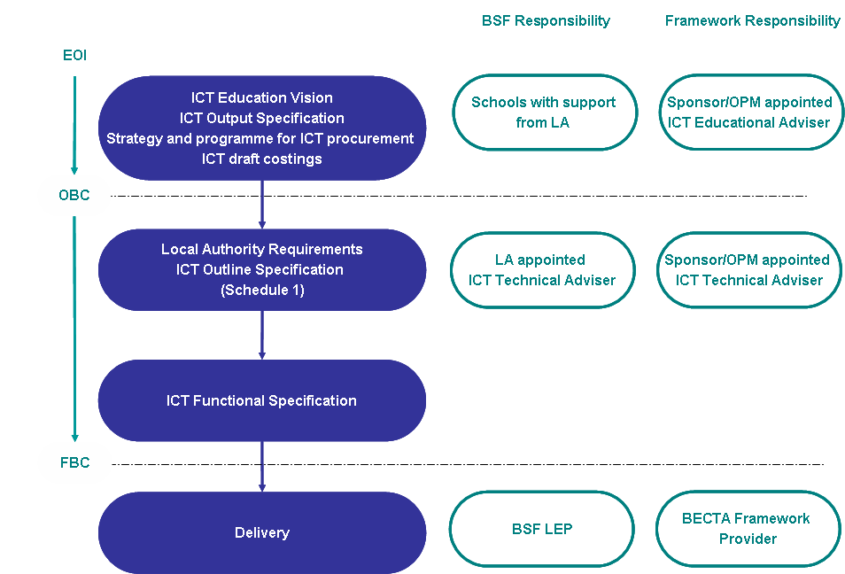

Figure 6.1: Typical ICT Design Development Process
  - Milestones in the ICT and Design Development Process

The key milestones in the ICT and design development process are;

- Approval of the ICT Vision
- Approval of the Outline Business Case by the PfS (with DfE endorsement)
- Appointment of the Selected Panel Member (for PfS Contractors Framework Projects)
- Selection of Preferred Bidder (for Academies delivered wholly through BSF or where ICT services are to be delivered through BSF procurement vehicle)
- Selection of Framework Member from Becta ICT Infrastructure Framework (for non-BSF projects)
- Approval of Final Business Case by PfS (with DfE endorsement)
- Contract Award
- Practical Completion
- Commissioning and Testing

Appendix A

Glossary of Terms

BSF | Building Schools for the Future  BSF is the biggest single government investment in improving school buildings for over 50 years. The aim is to rebuild or renew every secondary school in England over a 10-15 year period.
DfE | Department for Education
D&B | Design and Build  The arrangements in which a single contractor will be responsible for both the design and construction of the building project.
EOI | Expression of Interest  The EOI outlines the proposed vision for an Academy, including information on its ethos, specialism, proposed size, age range etc.
FA | Funding Agreement  The FA is a legally binding document that sets out the boundaries for the funding and operation of the Academy.
FAM | Funding Allocation Model  PfS will provide the LA a funding envelope for a group of schools in a project or for single Academies in PfS Contractors Framework projects. The envelope is calculated using the FAM.
FBC | Final Business Case  The FBC is prepared after the appointment of a Selected Panel Member and confirms that the project is affordable, proper management arrangements are in place, and the main contractual terms. On approval, PfS will release funds for the building project.
KPI | Key Performance Indicator  The KPIs will measure the ongoing performance of the framework contractors.
LA | Local Authority
LEP | Local Education Partnership  A LEP is a vehicle designed to create a partnership between an LA and a PSP to deliver new schools across an estate.
OBC | Outline Business Case  The OBC is prepared before starting procurement. It sets out the options for a project, cost and affordability estimates, management arrangements and confirms support for the project. Procurement cannot start until the OBC is approved by PfS.
OJEU | Official Journal of the European Union  All major public procurements must be advertised in the OJEU.
PMC | Project Management Company  External consultants appointed by the DfE on behalf of the Academy Sponsors to execute all of the activities required in order to establish the Academy, as set out in the PBS.
PBS | Product Breakdown Structure  Formal scope of services for the PMC, which is split into the Feasibility and Implementation stages of an Academy scheme. The PBS excludes any procurement activities for new/refurbished buildings, as these are carried out by the Local Authority.
PfS | Partnerships for Schools  PfS is a Non-Departmental Public Body (NDPB), wholly owned by the DfE
PSP | Private Sector Partner
SfC | Strategy for Change  The Strategy for Change (SfC) is the first formal component of the BSF approvals process. It is designed to capture both the local authority’s strategy for secondary education and the requirements that strategy places upon the physical school estate.

